

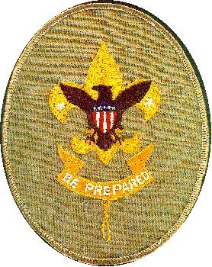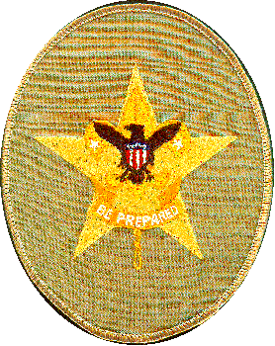
12 Nov 2016

To Whom it May Concern:

Dear Sir:

<name> is an Eagle Scout candidate with Troop 227, from Huntington Beach, California. As part of the Eagle Scout requirements, he must identify, plan, fundraise, organize and manage a significant service project for the local community. These Eagle projects are not done for Scouting, but are done for community organizations.

<name> may be approaching you for a donation to support this worth project. This letter is to confirm that he is working on an Eagle Project for our Troop, and to provide a contact in case of any questions. Any donations are tax deductible.

<name> is an excellent young man, and we strongly recommend him to you.

If you wish to contact us, <name> Scoutmaster is Bill Hencke, who may be reached at 714-336-0209 (phone number), and I am the Troop Committee Chairman Wallace McClure. I can be reached at 714-814-4926 or via email at wallace.mcclure@gmail.com

Sincerely,

Name

Wallace McClure
Troop 227 Committee Chair
.
Boy Scouts of America Huntington Beach California
Sponsored by the St. Bonaventure Men's Club

